G7- How to Set Up the Password Protect Web Directory in Apache

Installing the Apache Utilities Package
sudo apt install apache2-utils

Configure Apache to Allow .htaccess Authentication
You can do this by editing the Apache config file:
sudo nano /etc/apache2/apache2.conf
Find the section that begins with the Directory "/var/www/html" and change the line from AllowOverride none to AllowOverride AuthConfig
Options Indexes FollowSymLinks
AllowOverride AuthConfig
Require all granted
Save and close the file.

Create the Password File
sudo htpasswd -c /etc/apache2/.htpasswd authuser1
This will ask you to supply and confirm a password for authuser1.
password : authuser1
If you want to add another user, then leave out the -c argument with htpasswd command.
Now, to create another authentication for a second user, authuser2:
sudo htpasswd /etc/apache2/.htpasswd authuser2
password : authuser2
student@may29:~$ sudo htpasswd /etc/apache2/.htpasswd tram
Pw: tram

You can see the user name and the encrypted password for each record by running:
sudo cat /etc/apache2/.htpasswd
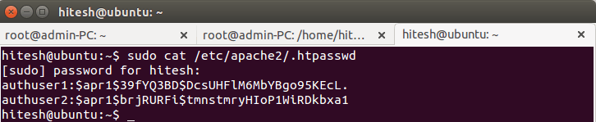
You need to grant permission to the “www-data” user to be able to read the .htpasswd file.
sudo chown www-data:www-data /etc/httpd/.htpasswd
sudo chmod 0660 /etc/httpd/.htpasswd
Lenh dung la
(base) b2204973@client:~$ sudo chown www-data:www-data /etc/apache2/.htpasswd
(base) b2204973@client:~$ sudo chmod 0660 /etc/apache2/.htpasswd
(base) b2204973@client:~$

Gap loi 500 thi phan quyen lai:
student@may29:~$ sudo chown root:apache /etc/apache2/.htpasswd
student@may29:~$ sudo chmod 640 /etc/apache2/.htpasswd
student@may29:~$ sudo systemctl restart apache2

Configure Apache Password Authentication
You need to create an “.htaccess” file in the web directory you wish to restrict. In this example I will create an “.htaccess” file in the “/var/www/html/” directory to restrict the entire document root.
sudo nano /var/www/html/.htaccess
Add the following content:
AuthType Basic
AuthName "Restricted Content"
AuthUserFile /etc/apache2/.htpasswd
Require valid-user
- AuthUserFile: This option specifies the location of user credentials.
- require valid-user: This indicates that only successful authenticated requests may load the page.
Save and close the file, and restart Apache to make these changes take effect.
sudo /etc/init.d/apache2 restart

Testing Password Authetication
Now on a remote machine, access your website in a web browser. You will be prompted with a user name and password to access web page.
b2204973@client:~$ hostname -I
172.16.125.190
b2204973@client:~$
curl -k -u authuser1:YourPassword https://172.16.125.190/
https://172.16.125.190/login.php

If you enter the correct user credentials, you will be allowed to access the content. If you enter the wrong user credentials or hit “Cancel,” you will see the Unauthorized error page.

8- Setting Up Fail2ban to Protect Apache from a DDOS Attack

Installing Fail2Ban
sudo apt update
sudo apt install fail2ban

Configure fail2ban for Apache
To create new “jail.local” file, run:
sudo nano /etc/fail2ban/jail.local
Add the following content:
[apache]
enabled = true
port = http,https
filter = apache-auth
logpath = /var/log/apache2/*error.log
maxretry = 3
findtime = 600
ignoreip = 192.168.1.227

[apache-noscript]
enabled = true
port = http,https
filter = apache-noscript
logpath = /var/log/apache2/*error.log
maxretry = 3
findtime = 600
ignoreip = 192.168.1.227

[apache-overflows]
enabled = true
port = http,https
filter = apache-overflows
logpath = /var/log/apache2/*error.log
maxretry = 2
findtime = 600
ignoreip = 192.168.1.227

[apache-badbots]
enabled = true
port = http,https
filter = apache-badbots
logpath = /var/log/apache2/*error.log
maxretry = 2
findtime = 600
ignoreip = 192.168.1.227

Ignoreip là ip không bị chặn
Change findtime restart, open the “jail.conf” configuration file.
sudo nano /etc/fail2ban/jail.conf
in [DEFAULT] change the following content:
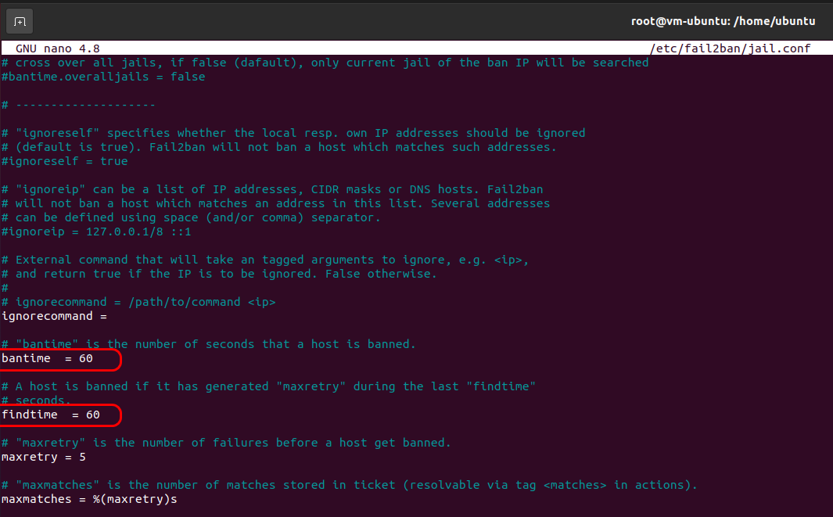
Save and close the file, then restart fail2ban for the changes to take effect.
sudo /etc/init.d/fail2ban restart
You can verify the rules that were added by Fail2Ban in iptables using the following command:
sudo iptables -L
The output will look something like this:
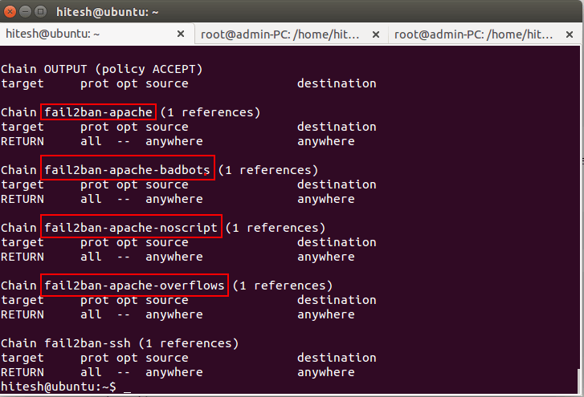
Note : You can find the details of each jail described below:
- [apache] : this jail is used to blo
- sudck failed login attempts.
- [apache-noscript] : this jail is used to block remote clients who are searching for scripts on the website to execute.
- [apache-overflows] : this jail is used to block clients who are attempting to request suspicious URLs.
- [apache-noscript] : this jail is used to block remote clients who are searching for scripts on website to execute.
- [apache-badbots] : this jail is used to block malicious bot requests.
Note : You can find the details of each rule described below.
- enabled : this option means Apache protection is on.
- port : this option specifies the services that fail2ban monitors.
- filter : this option refers the config file located in the /etc/fail2ban/filter.d/ directory.
- logpath : this option specifies the location of log file.
- bantime : this option specifies the number of seconds that a remote host will be blocked from the server.
- maxretry : this option specifies the number of failed login attempts before a remote host is blocked for the length of the ban time.
- ignoreip : this option allows you to whitelist certain IP addresses from blocking.

Check Fail2ban Banning Status
Once jails are activated, you can check fail2ban using the fail2ban-client command:
sudo fail2ban-client status
You can see a list of all of the jails you enabled.
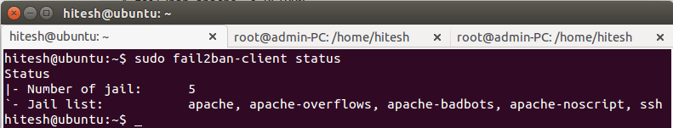
To see the status of a particular jail like apache, apache-badbots by running the following commands:
sudo fail2ban-client status apache
The output looks like this:
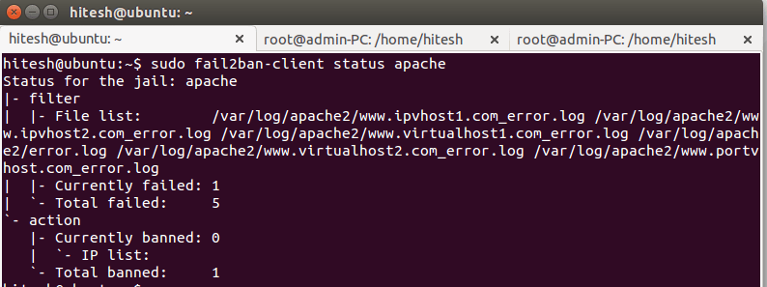
You can also manually set ban or unban IP addresses.
For example, to ban an IP address (192.168.1.20) with an apache jail:
sudo fail2ban-client set apache banip 192.168.1.20
To unban an IP address (192.168.1.21) with an apache jail:
sudo fail2ban-client set apache unbanip 192.168.1.21

Check the status with the fail2ban-client command:
sudo fail2ban-client status apache
You will see your IP address being blocked from the site.
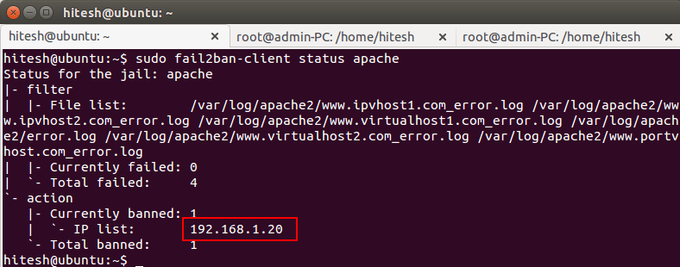

Bonus
Ban hoặc unban IP thủ công:
sudo fail2ban-client set apache banip 192.168.1.20
sudo fail2ban-client set apache unbanip 192.168.1.21

Vô thi làm cái này nè, cái ở trên là lý thuyết thôi

Password
sudo apt install apache2-utils
sudo nano /etc/apache2/apache2.conf
Thêm:
Options Indexes FollowSymLinks
AllowOverride AuthConfig
Require all granted
Vào
<VirtualHost *:443>
ServerAdmin webmaster@localhost
ServerName localhost
DocumentRoot /var/www/html
SSLEngine on
SSLCertificateFile /etc/apache2/ssl/ca.crt
SSLCertificateKeyFile /etc/apache2/ssl/ca.key
ErrorLog ${APACHE_LOG_DIR}/error.log
CustomLog ${APACHE_LOG_DIR}/access.log combined
<Directory /var/www/html>
Options Indexes FollowSymLinks
AllowOverride AuthConfig
Require valid-user
</Directory>
</VirtualHost>
sudo htpasswd -c /etc/apache2/.htpasswd authuser1
Passwd authuser1
sudo htpasswd -c /etc/apache2/.htpasswd authuser2
Passwd authuser1

Tao:
sudo nano /var/www/html/.htaccess
Them vao:

AuthType Basic
AuthName "Restricted Content"
AuthUserFile /etc/apache2/.htpasswd
Require valid-user

Cap quyen:
Lenh dung la
(base) b2204973@client:~$ sudo chown www-data:www-data /etc/apache2/.htpasswd
(base) b2204973@client:~$ sudo chmod 0660 /etc/apache2/.htpasswd
(base) b2204973@client:~$

Gặp lỗi 500 thì phân quyền lại
student@may29:~$ sudo chown root:apache /etc/apache2/.htpasswd
student@may29:~$ sudo chmod 640 /etc/apache2/.htpasswd
student@may29:~$ sudo systemctl restart apache2
b2204973@client:~$ hostname -I
172.16.125.190
b2204973@client:~$
curl -k -u authuser1:YourPassword https://172.16.125.190/
https://172.16.125.190/login.php

FAIL2BAN

sudo apt install fail2ban
sudo nano /etc/fail2ban/jail.local
[apache]
enabled = true
port = http,https
filter = apache-auth
logpath = /var/log/apache2/*error.log
maxretry = 3
bantime = 5
findtime = 10
ignoreself = false
ignoreip = 192.168.1.227

[apache-noscript]
enabled = true
port = http,https
filter = apache-noscript
logpath = /var/log/apache2/*error.log
maxretry = 3
findtime = 10
ignoreip = 192.168.1.227

[apache-overflows]
enabled = true
port = http,https
filter = apache-overflows
logpath = /var/log/apache2/*error.log
maxretry = 3
findtime = 10
ignoreip = 192.168.1.227

[apache-badbots]
enabled = true
port = http,https
filter = apache-badbots
logpath = /var/log/apache2/*error.log
maxretry = 3
findtime = 10
ignoreip = 192.168.1.227
sudo nano /etc/fail2ban/jail.conf
Chinh
Bantime = 5
Them
ignoreself = false

sudo fail2ban-client status apache
Lan dau 4 lan sau 3

Tạo Blacklist
Bước 1: Edit file tùy chỉnh (tránh sửa jail.conf):
sudo nano /etc/fail2ban/jail.local
Thêm jail sau:
[blacklist]
enabled = true
filter = blacklist
logpath = /var/log/blacklist.log
bantime = -1
findtime = 1
maxretry = 1

2. Tạo filter đơn giản
File: /etc/fail2ban/filter.d/blacklist.conf
sudo nano /etc/fail2ban/filter.d/blacklist.conf
[Definition]
failregex = ^<HOST>$
Nghĩa là: trong file log dòng nào là IP → ban IP đó.
- Muốn ban IP nào → ghi vào file log
ban 2 ip:
echo "10.0.0.0" | sudo tee -a /var/log/blacklist.log
echo "10.0.0.1" | sudo tee -a /var/log/blacklist.log
Ban dãy 192.168.1.0–10:
for i in {0..10}; do
echo "192.168.1.$i" | sudo tee -a /var/log/blacklist.log
done

